**User Stories**

# Sign up Page

**Features: Create an account 2**

* In order to create an account, student should register on the system

**Scenario 1: Required information for registration**

* Given the student wants to create an account
* And the student does not have an account
* When the student registers on the system by providing
  + Username
  + Password
  + Address
  + Email Address
  + Phone Number

**Scenario 2: Username already existed**

* Given the username already existed
* Display message below the username box
* The student input another username

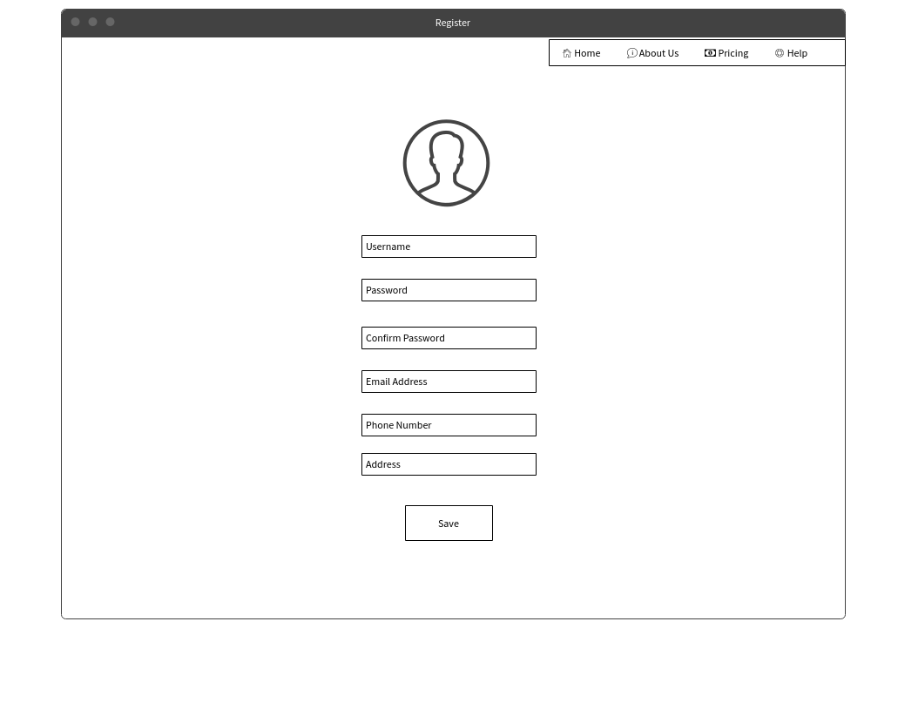

# Login Page

**Features: log-in 2**

* In order to use the system, user should login to the system

**Scenario 1: Successful Log-in**

**Student, Teacher**

* Given the student wants to log in
* Login successfully, the system redirects the student to “My Courses” page
* Redirect to “Admin dashboard” page

**Admin**

* Login successfully, the system redirects the student to “Courses” page

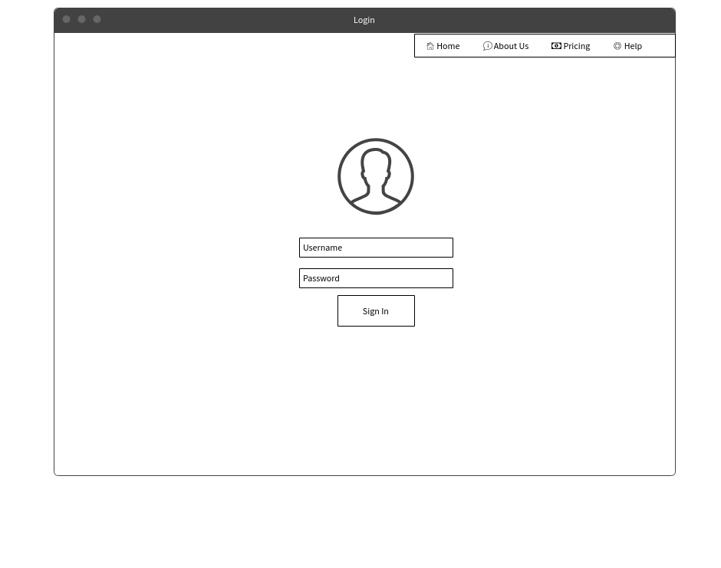

# Courses Page

**Features: View all Courses 2**

**Student, Teacher**

* The system displays a list of available courses
* Click into course name, the system will redirect user to “Course Detail”

**Admin**

* The system displays a list of available courses
* The system display “Create” button
* The system display “Delete” and Assign button
* Click into course name, the system will redirect user to “Course Detail”

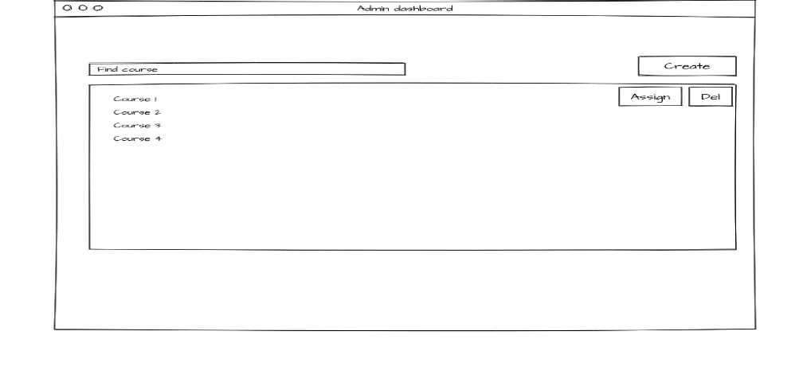

**Features: Create a new course 2**

**Admin**

* Admin clicks on “Create” button
* The system link to “Course Create” page

**Features: Delete a course 2**

**Admin**

* Admin clicks on “Delete” button
* The system display an confirmation message

**Scenario 1: Admin clicks “**Yes”

* Remove this course from database

**Scenario 2: Admin clicks “**No”

* No 🡪 Nothing happens

**Features: Assign teacher to course 2**

**Admin**

* Admin clicks on “Assign” button
* The system display a modal with “Teacher” list.
* Admin choose “the teacher” for that course
* Admin clicks on “Assign” button

# My Course Page

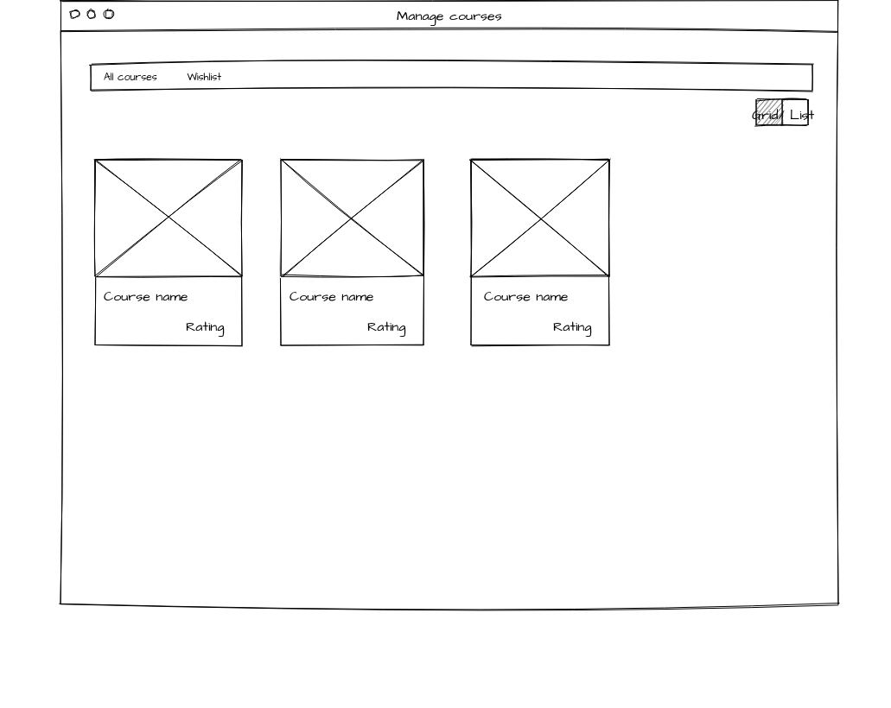

**Features: Move in “Course Detail” Page 2**

**Student, Teacher**

* The user clicks on Course card
* The system link user to “Course Detail” page

**Features: Read your course 2**

**Student, Teacher**

* The user can choose grid or list view to watch his/ her courses.

**Features: Wishlist 4**

* The user can see courses that they bookmarked.
* User can easily enroll those courses when they adapt conditions.

# Course Detail Page

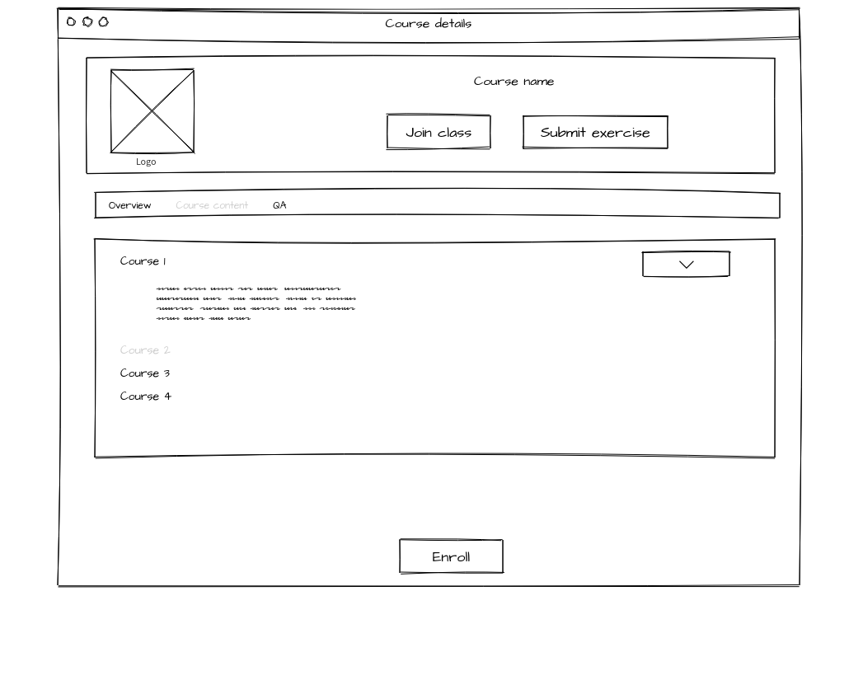

**Features: Join class 2**

**Student, Teacher, Admin**

* User clicks on “Join class” button
* The system will redirect user to “ClassRoom”

**Features: Submit exercise 4**

**Student, Teacher, Admin**

* User clicks on “Join class” button
* The system will redirect user to Moodle

**Features: View course’s overview 2**

**Student, Teacher, Admin**

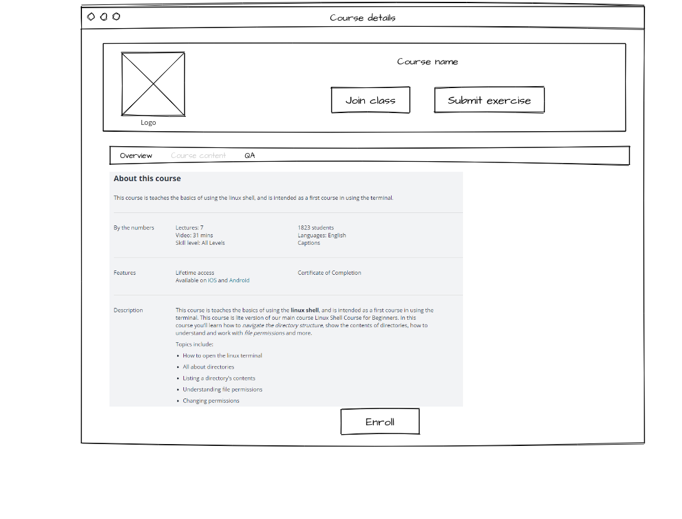

* The system displays:
  + Description
  + By the numbers
    - Lectures
    - Class duration
    - Skill level
    - Number of students
    - Language
  + Instructors

**Features: View course’s content 3**

**Student, Teacher, Admin**

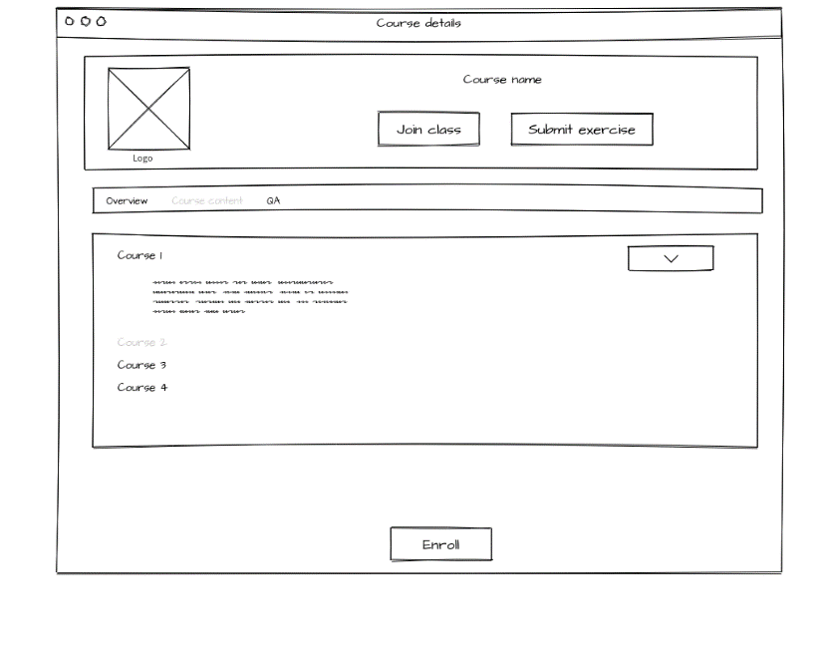

* The system displays a list of lectures.
* User clicks button “arrow down” to show the lecture’s description

**Features: Enroll in Courses 2**

* In order enroll in course, student should be logged in the system

**Scenario 1: Enroll in Course**

* Given the student wants to enroll in certain course
* The student clicks on the enroll button
* Then the student should receive an email confirm he/she has enrolled in the chosen course
* The system reloads “Course Detail” page.

# Class Room Page

**Features: Video Conference 2**

* In order to have a video conference, student should be logged to the system and enroll in a course
* The student is joining a class
* The teacher is online

**Scenario 1: Video conference**

* Given the student want to have video conference with teacher
* The student checks the list of online students/teacher
* Student join the video conference with teacher

**2.2.1.5 Function Requirement 1.5**

**ID: FR5.1**

**Features: Public Chat 1**

* In order to chat in the class, student should be logged to the system and enroll in a course
* The student(s) is/are joining a class

**Scenario 1: Public Chat**

* Given the student want to chat with teacher/other students
* The student check the list of online students/teacher
* The student types the content onto the content box.
* Student clicks send button
* Student sends message into the chat forum in class

**ID: FR5.2**

**Features: Private Chat 3**

* In order to chat in the class, student should be logged to the system and enroll in a course
* The student(s) is/are joining a class

**Scenario 1: Private Chat**

* Given the student want to chat with teacher/other students
* The student check the list of online students/teacher
* The student double click on the name of the person he/she want to chat or they click the setting button beside and then choose option “Communicate”
* The student types the content onto the content box.
* Student clicks send button
* Student sends message into the chat forum in class

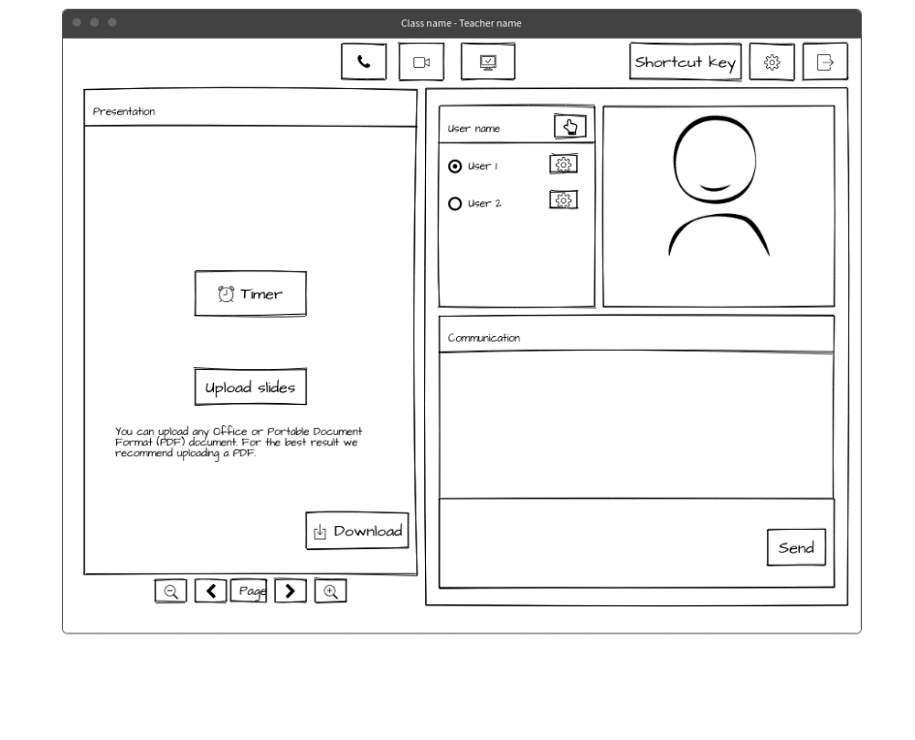

**2.2.1.6 Function Requirement 1.6**

**ID: FR6**

**Features: Raise your Hand / Question 2**

* In order to use Raise your Hand/ Question, student should be logged to the system and enroll in a course
* The student(s) is/are joining a class
* The teacher is online

**Scenario 1: Raise your Hand/Question**

* Given the student want to raise his/her hand with the teacher
* The student clicks on the video screen on the bottom right of the screen
* The student chooses hand icon “Raise/Lower your Hand”
* The system will display the notification on teacher browser
* The student raises his/her hand or question

**2.2.1.7 Function Requirement 1.7**

**ID: FR7**

**Features: Exercise 4**

* In order to do/submit exercise, student should be logged to the system and enroll in a course
* The student(s) is/are joining a class
* The teacher is online

**Scenario 1: Do Exercise Online**

* Given the student want to do exercise online
* The student clicks on the link the teacher submits in the chat forum
* The browser opens a modal (form, multiple choices…)
* The student finishes the exercise(s)
* The student clicks submit button in the modal

**2.2.1.8 Function Requirement 1.8**

**ID: FR8**

**Features: Read Slide/ Course Materials 1**

* In order read slide, student should be logged to the system and enroll in a course
* The student(s) is/are joining a class

**Scenario 1: Read Slide / Course Materials**

* The user joins the class
* User read the slide in the left side of the screen
* User can zoom slide

**Scenario 2: Navigate Slide/ Course Materials**

**Teacher**

* Given the admin want to navigate in slide/ course material
* The teacher joins the class
* The teacher navigates through arrow button of the bottom of the slide

**Scenario 3: Upload Slide/ Course Material**

**Teacher**

* Given the admin want to upload slide/ course material
* The teacher joins the class
* The teacher clicks the upload button at the left corner of the screen
* The teacher chooses the slide/ course material for the class
* The teacher uploads the slide/ course material to the class

**2.2.1.9 Function Requirement 1.9**

**ID: FR9**

**Features: Disable Communication Yourself 1**

* In order to disable the communication, student should be logged to the system and enroll in a course
* The student(s) is/are joining a class

**Scenario 1: Mute his/herself**

* Given the student want to mute his/herself micro in the video conference
* The student clicks on the video screen on the bottom right of the screen
* The student clicks the micro icon on the screen
* The student mutes his/her micro

**Scenario 2: Disable the Camera**

* Given the student want to disable his/herself camera in the video conference
* The student clicks on the video screen on the bottom right of the screen
* The student clicks the camera icon on the screen
* The student disables his/her camera

**2.2.1.10 Function Requirement 1.10**

**ID: FR10**

**Features: Setting Button besides User 3**

* In order to use the taskbar button, student should be logged to the system and enroll in a course
* The student(s) is/are joining a class

**Scenario 1: Profile 3**

* Given the student want to check his/her profile
* The student clicks on profile link
* The system display the profile by using a modal

**Scenario 2:  Kick a student out of class 3**

* Teacher clicks on “Kick” option from setting button
* The student is kicked get a notification and redirect to “his courses” page
* He can’t get in this class in that day

**Feature: Mute Students 2**

* Given the teacher want to mute student(s) micro in the video conference
* The teacher clicks on the list of the online students in class
* The teacher clicks on the micro icon of student(s)
* The teacher mutes the selected student

**Feature: Disable Students Camera 2**

* Given the teacher want to disable student(s) camera in the video conference
* The teacher clicks on the list of the online students in class
* The teacher clicks on the camera icon of student(s)
* The teacher disables the selected student